**Stella Process Flow**

**Login Screen**

This is where you enter your login details for Stella. This is a login specific to Stella. There is possibly an AD group related to this? (need to check).

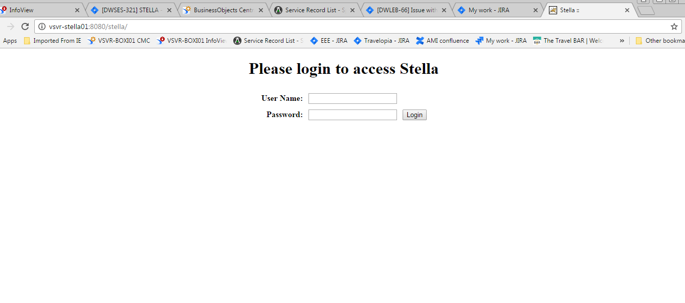

**Front Screen**

From this screen you are able to access the various functions within Stella.

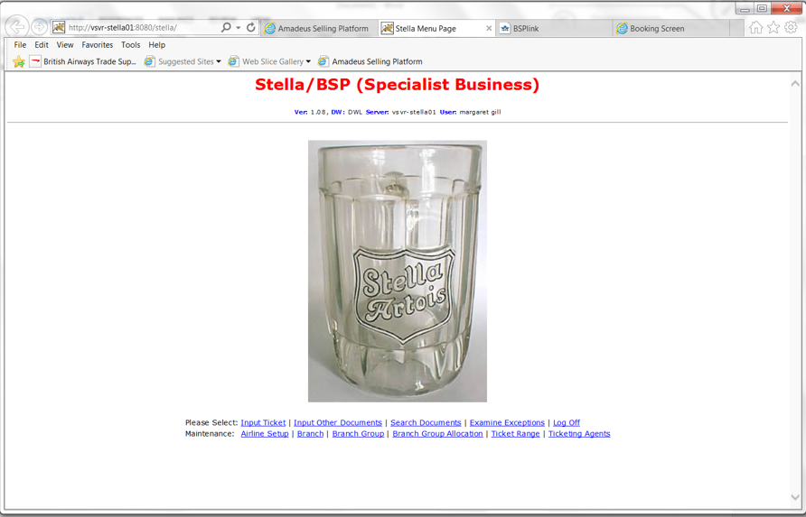

**Input Ticket**

This is the screen used when a ticket requires manual entry, there is a drop down menu against Document Type.

When entering an EMD (Electronic Misc Document), they have to enter it into Stella as am Amadeus Ticket. There is a drop down menu against Airline, although if you know numerical prefix it will populate the airline name for you. The same applies to the IATA number. You will also notice the E-Ticket box in the top right hand corner which needs to be ticked.

Repeat Ticket

This is used for multiple pax, it moves ticket number on on by one.

Conjunction Ticket

If the ticket we are entering is a conjunction you are able to click the conjunction button at the bottom of the screen and it populates all the information for you for the 2nd ticket. The repeat ticket option is used if all details are the same we can then just amend the name.

Void Ticket

The void button will show the document as voided. Can only be voided on the same day its issued

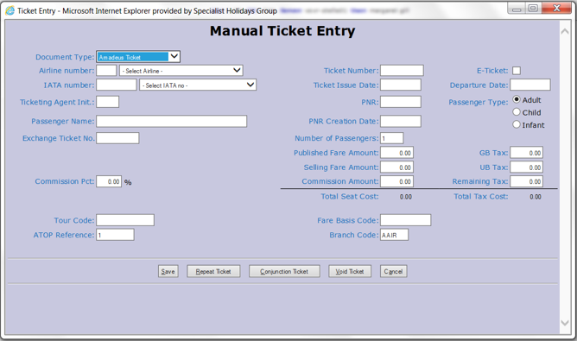

**Input other Documents**

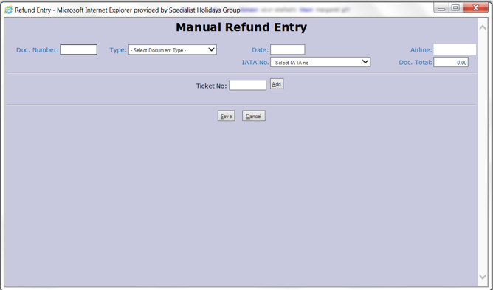

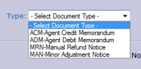

**The screen is called “Manual Refund Entry”**

ADMS – Agency Debit Memo (invoice from airline for either error on ticket for a payment of a fee from the airline or a deposit) – can be linked to multiple tickets. Need to be able to see on a ticket that it has an ADM, can do this at the moment. An ADM is added per ticket (4 tickets would be 4 ADMS and they split the cost by the number of tickets).

ACMS – Agency Credit Memo (when the airline are refunding deposits, errors that were not errors, tickets and commission for sales). An ACM is added per ticket (4 tickets would be 4 ACMS and they split the cost by the number of tickets).

MRN - Manual Refund Notice - where we refund a ticket. These come in from Amadeus but they still have to be inputted manually. This is also used for RAA (Refund Application Authority) Where we apply to the airline for a refund through BSP as for some reason it is not possible to refund through Amadeus.

MAN – Minor Adjustment Notice - Comes from BSP, where we have paid too much tax on a ticket so we claim it back for the airline.

**Search Documents**

Search Document screen is the “Document Search”

Search by PNR/Airline/PAX/Departure Date etc.

You can use any of the above criteria to retrieve a document (ATOP ref refers to Travelink Ref)

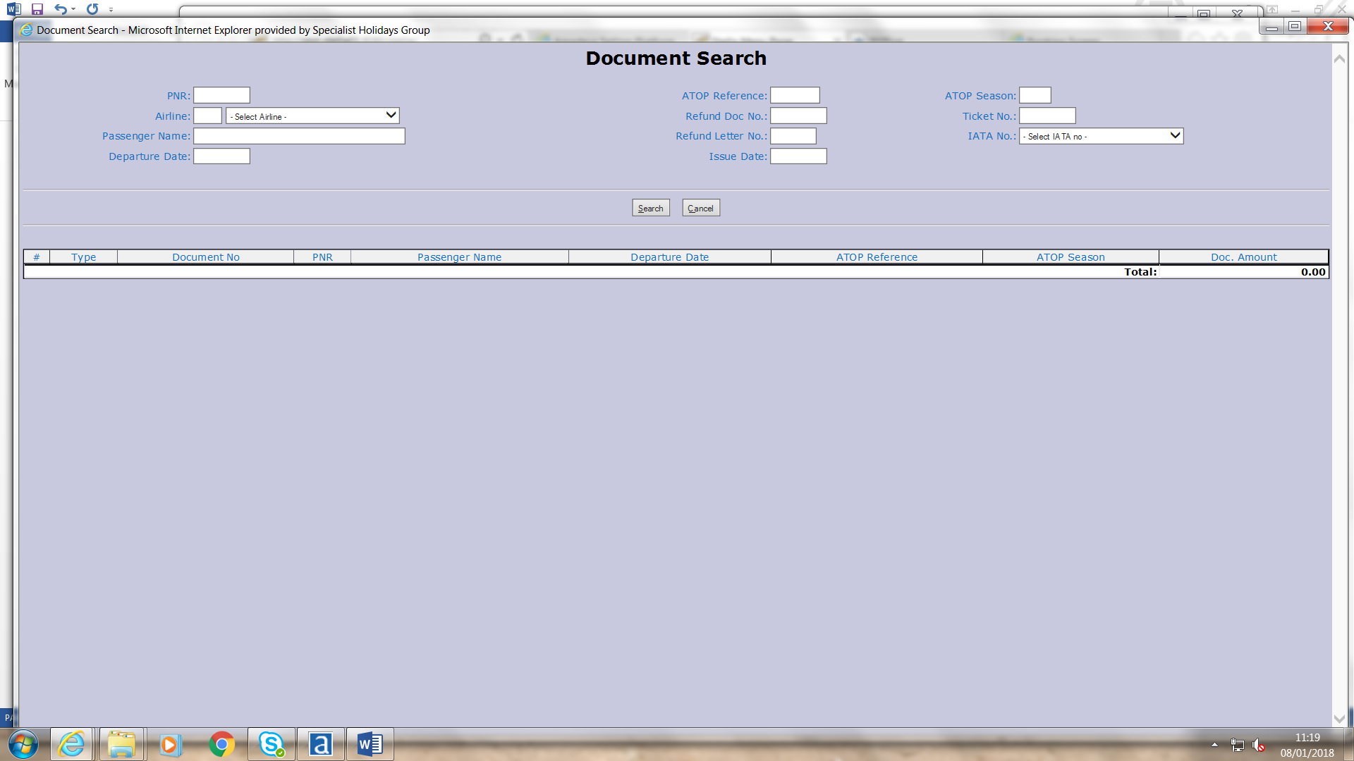

**Examine Exceptions – this screen is not used**

**Maintenance Screens**

**Airline setup**

The screen is called “Airline Mapping” - When you want to issue a ticket for a new Airline needs to be added in here before issuing a ticket. Buttons are “add airline” and “add user” (add user seems to map users to airlines but not sure if this is used).

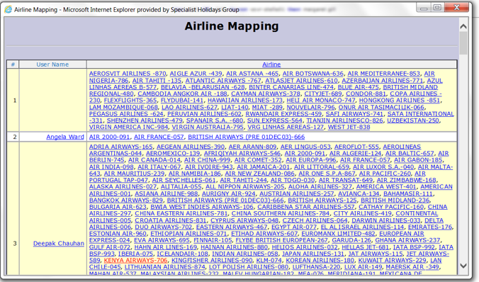

**Branch**

The screen is called Branch Maintenance

Branch code is essentially the brand eg. H&J (all specialist) mapping them to departure years

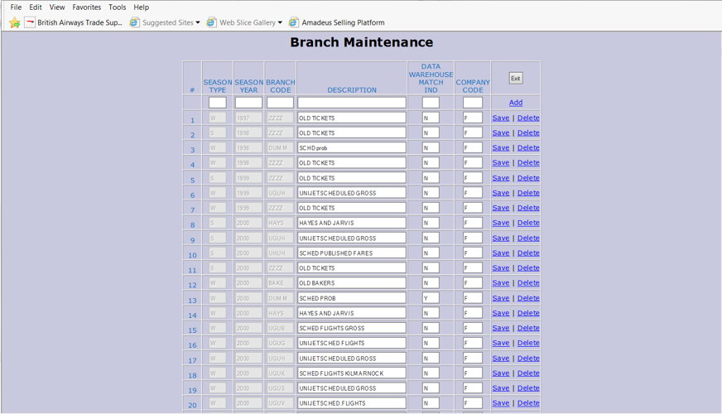

**Branch Group**

The screen is Branch Group Maintenance – This is used for a new branch code for example a new product

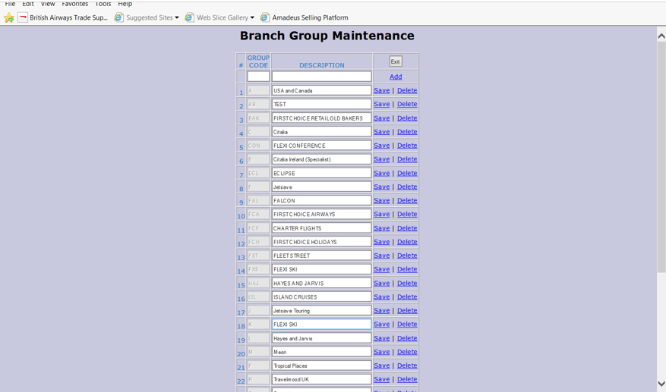

**Branch Group Allocation**

Same name as button – brand identifying letter, season which was W/S but now needs to be Y for year. Then Departure Year and then Branch Code (eg. SOVE)

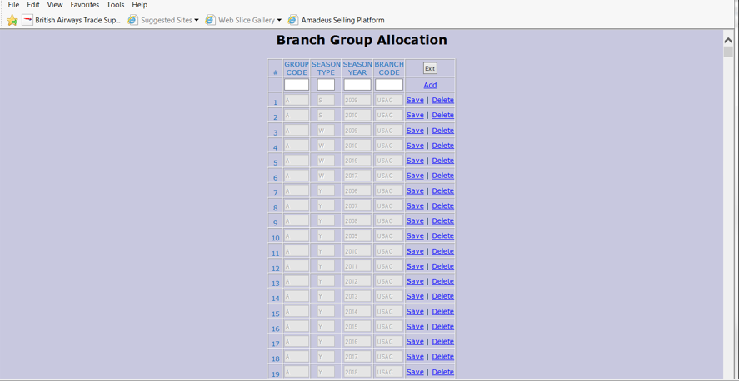

**Ticket Range – Don’t use at all**

**Ticketing Agents**

Ticketing Agents – Ticketing Agent Maintenance is the name of the screen. Here you add in Ticketing agent initials and their name so that Stella accepts the file from Amadeus and knows who the ticketing agent is.

